

Practices for Secure Software Report

Table of Contents
Document Revision History 3
Client 3
Instructions 3
Developer 4
1. Algorithm Cipher 4
2. Certificate Generation 4
3. Deploy Cipher 4
4. Secure Communications 4
5. Secondary Testing 4
6. Functional Testing 4
7. Summary 4
8. Industry Standard Best Practices 4

Document Revision History

Version | Date | Author | Comments
1.0 | 10-16-26 | Dustin Schroeder

Client



Developer
Dustin Schroeder

Algorithm Cipher

For Artemis Financial, I recommend using modern cryptographic algorithms that address the specific security function being performed rather than relying on one algorithm for every purpose. For data integrity, I implemented SHA-256 to generate a cryptographic checksum. SHA-256 belongs to the SHA-2 family and produces a fixed 256-bit digest regardless of the size of the original input. The digest can be used to detect whether data has been modified because changing the input produces a different hash value. A cryptographic hash is a one-way operation and therefore does not require an encryption or decryption key.

Encryption has a different purpose from hashing because it protects confidentiality rather than verifying integrity. Symmetric algorithms such as AES use the same secret key for encryption and decryption and are appropriate for protecting data. Modern symmetric encryption supports key sizes such as 128 and 256 bits. Asymmetric algorithms such as RSA instead use mathematically related public and private keys. In a public-key system, the private key must remain protected while the public key can be distributed. This makes asymmetric cryptography useful for functions such as digital signatures, certificates, and establishing trust between communicating systems.

Random numbers are also important to modern cryptography. Cryptographically secure random values are used when generating keys and other cryptographic parameters so that an attacker cannot easily predict them. Microsoft security guidance similarly recommends AES for symmetric encryption and cryptographically strong random values where initialization vectors are required.

Cryptographic algorithms have continued to evolve as computing power and attack techniques have improved. Older algorithms and protocols that were previously considered adequate have been replaced as weaknesses were discovered or their effective security became insufficient. Current practice therefore requires developers to select algorithms and key lengths that remain appropriate for the security requirements of the application rather than assuming that an older cryptographic technique remains secure indefinitely. NIST maintains standards and guidance covering areas including block ciphers, hash functions, digital signatures, random-bit generation, and key management.

Certificate Generation
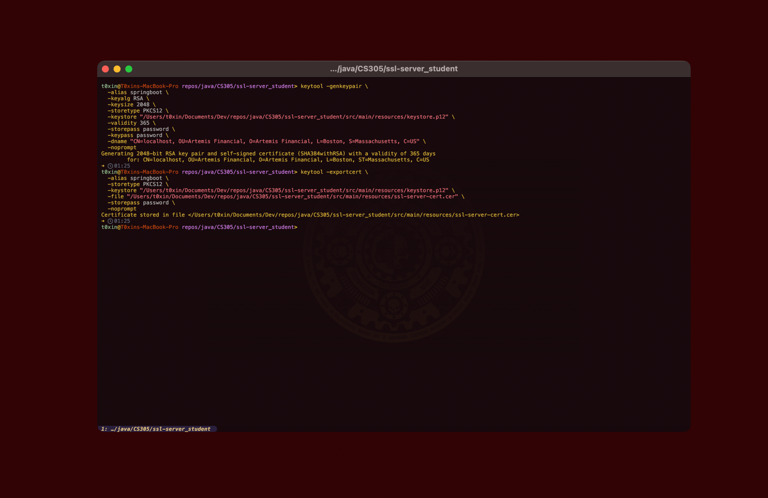
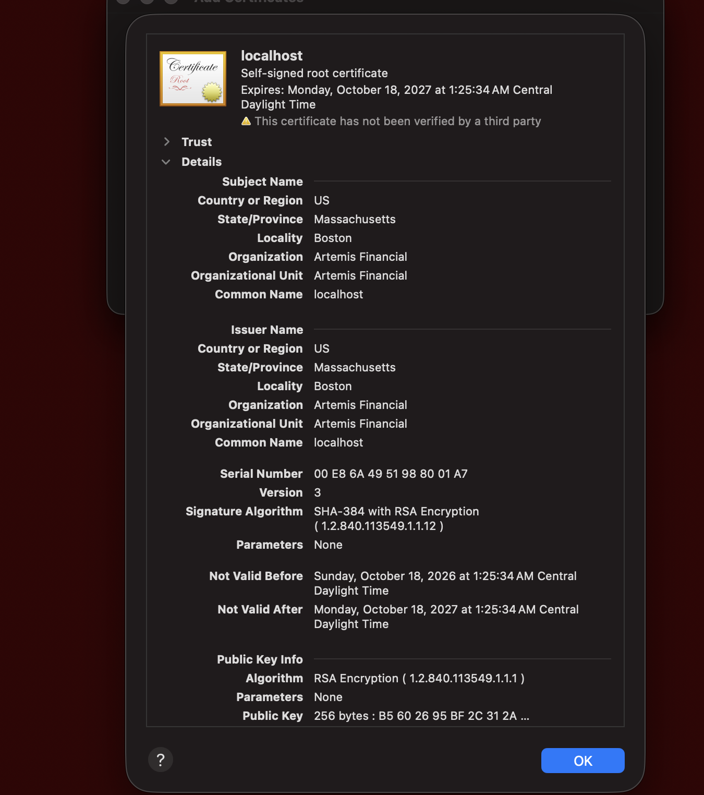

Deploy Cipher

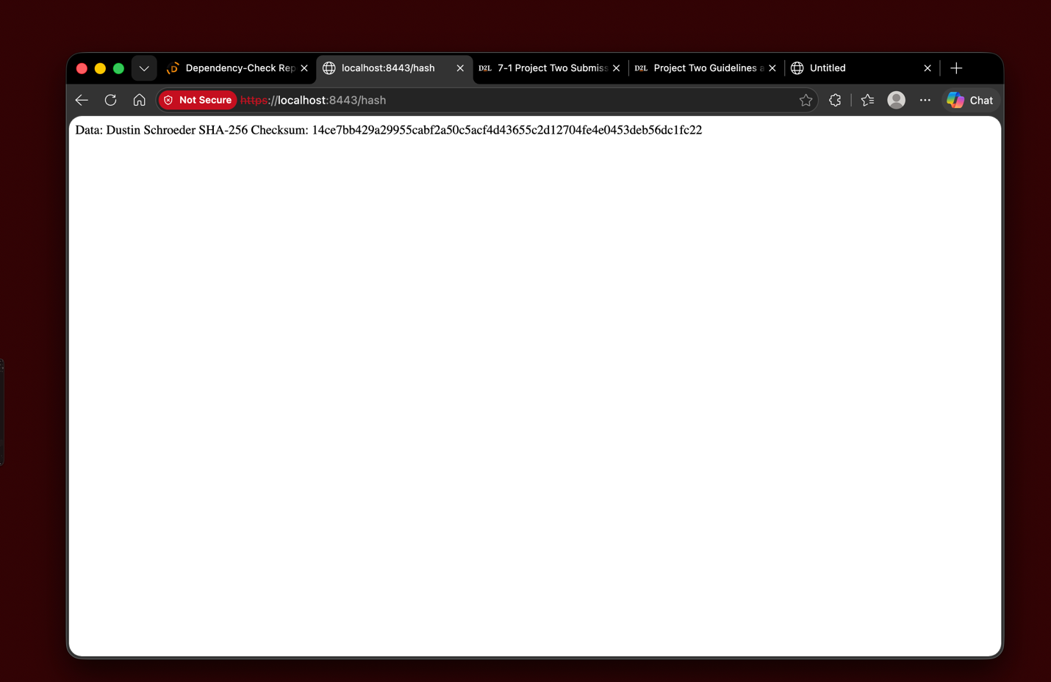

Secure Communications
Note: I am using the same screenshot as I already completed the engineering steps to arrive at https prior to taking screenshots. Also I wish to point out this is using https as requested but due to using a self signed cert and not using a CA or importing it directly into the client trust it will still show not-secure.

Secondary Testing

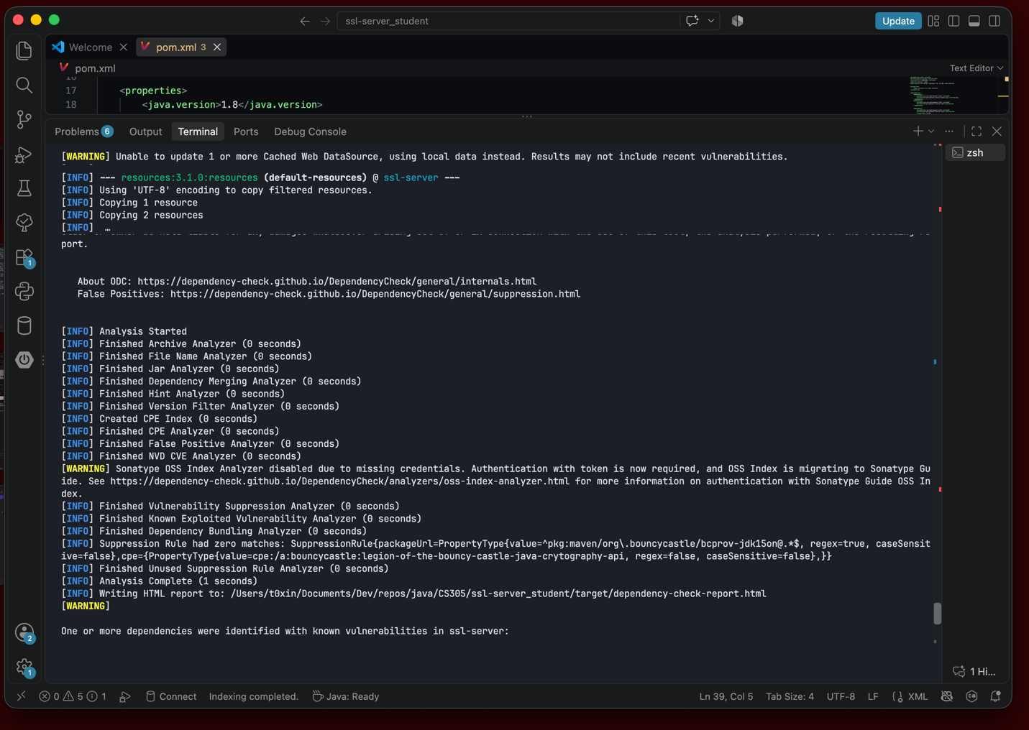

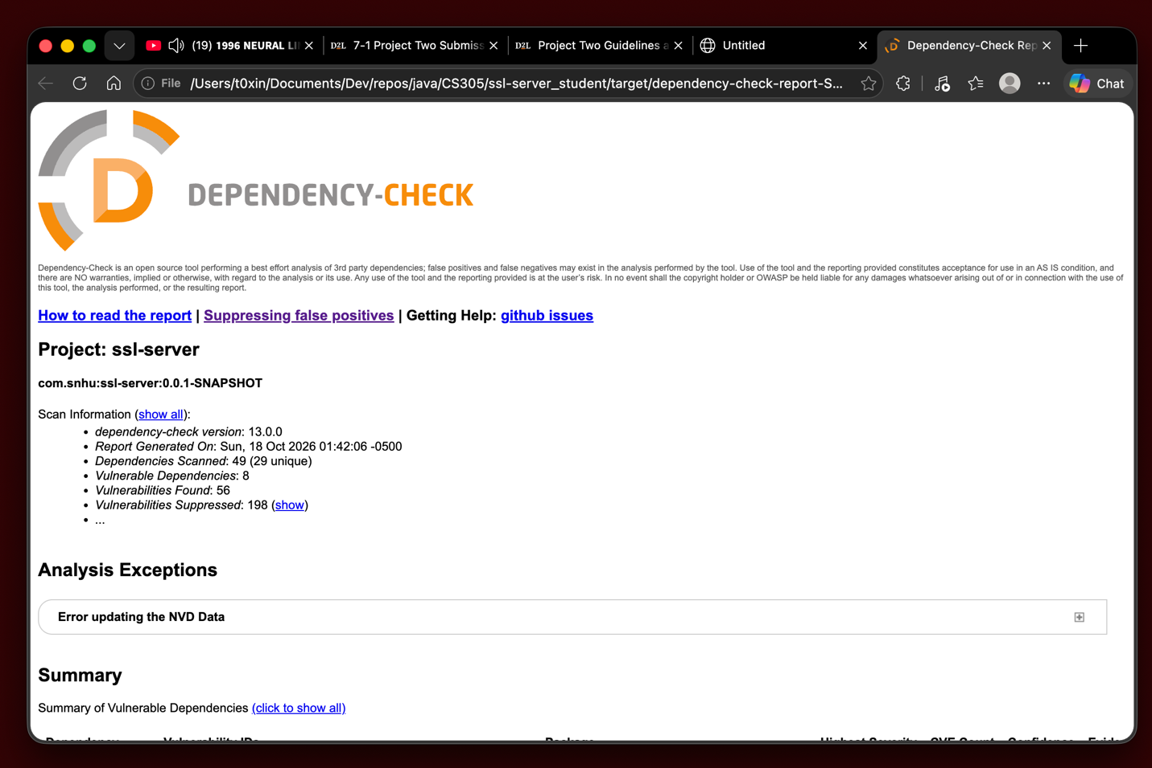

Functional Testing
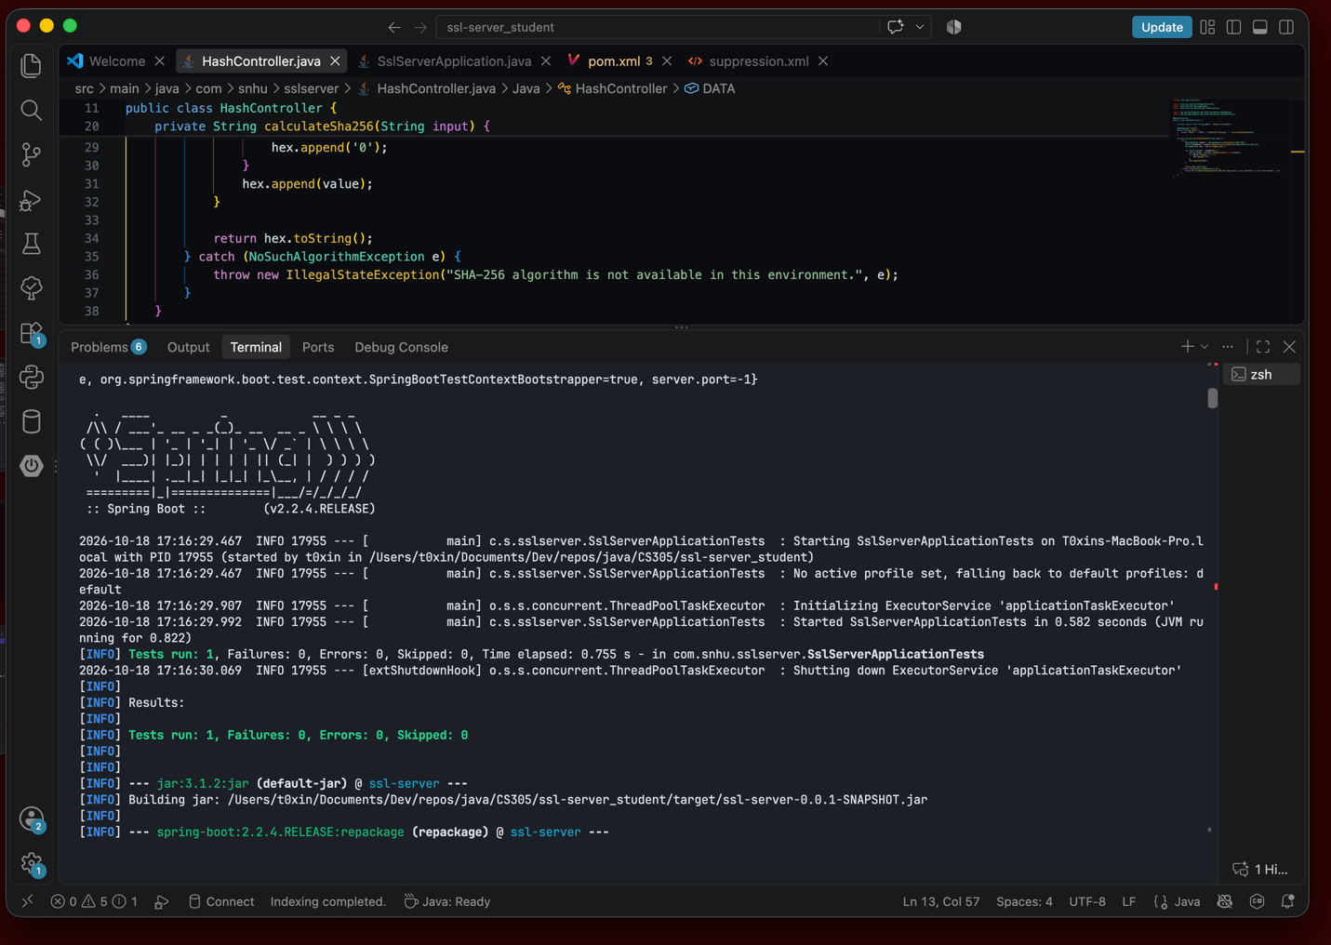

Summary
The Artemis Financial application was refactored to add multiple security controls. The primary modifications introduced SHA-256 hashing for data-integrity verification, certificate-based HTTPS communication, and the configuration necessary for the Spring Boot application to use the generated cryptographic material. After the changes were implemented, I tested the application both functionally and through dependency analysis to verify that the security changes did not prevent the existing application from operating correctly.
These changes correspond with several areas identified in the course vulnerability assessment process. The process diagram specifically calls for reviewing application cryptography, client/server security, code errors, and code quality, followed by targeted manual code review and a summary of findings and mitigations.

Industry Standard Best Practices

I applied secure-coding practices by using established cryptographic functionality. SHA-256 was used for cryptographic hashing, certificate-based HTTPS was used to protect client/server communications, and Java's existing security capabilities were used to perform these operations. This approach reduces the risk introduced by implementing custom security mechanisms when established and extensively analyzed options are available.

I also maintained the application's existing functionality by limiting the refactoring to changes required for the security objectives and then retesting the application. Successful compilation and execution established basic functional correctness, manual review examined the added logic, and Dependency-Check supplied an additional review of known risks associated with third-party components. The existing dependency findings were treated separately from the code introduced during refactoring rather than assuming that an automated scan could replace manual analysis.

